

EXAMINATION FOR MEMBERSHIP

WRITTEN PAPER

Friday 21 April 2006

REFERENCE MATERIAL FOR QUESTIONS 2, 7 and 8

Reference Material A – (Question 2)

Patient initiated outpatient follow up in rheumatoid arthritis: six year randomised controlled trial
Ethical approval: Local research ethics committee approval was given for the original two year trial and the subsequent four year extension.
Objectives To determine whether direct access to hospital review initiated by patients with rheumatoid arthritis would result in improved clinical and psychological outcome, reduced overall use of healthcare resources, and greater satisfaction with care than seen in patients receiving regular review initiated by a rheumatologist.
Design Two year randomised controlled trial extended to six years.
Setting Rheumatology outpatient department in teaching hospital.
Participants 209 consecutive patients with rheumatoid arthritis for over two years; 68 (65%) in the direct access group and 52 (50%) in the control group completed the study (P = 0.04).
Methods
We originally invited consecutive patients who had had rheumatoid arthritis for more than two years and who were attending for routine outpatient reviews to participate in a two year randomised controlled trial, irrespective of clinical status. Randomisation was performed blind, using computer generated numbers concealed in envelopes prepared by an independent party. If patients agreed to participate we then sought consent from their general practitioners. Patients who took part in the two year study were afterwards invited to continue the study for a further four years.

Table 1: Baseline characteristics. Figures are medians (interquartile range) unless stated otherwise.
 | Completed study (n=120)
 | Direct access group |  | Control group
 | No of patients | Median (IQ range) | No of patients | Median (IQ range) | P value*
Age (years) | 68 | 58.0 (48.3 to 65.0) | 52 | 57.0 (48.3 to 66.0) | 0.91
Disease duration (years) | 65 | 7.0 (4.0 to 13.0) | 51 | 10.0 (5.0 to 14.0) | 0.01
% female | 68 | 66.2% | 52 | 71.1% | 0.58
Outcome measure scale

Pain (0-10) | 68 | 3.00 (1.73 to 5.58) | 52 | 3.10 (1.42 to 4.80) | 0.87
Early morning stiffness (0-1440 min) | 68 | 30.0 (10.0 to 60.0) | 52 | 30.0 (10.0 to 60.0) | 0.49
Grip strength (0-72 kg) :
Right hand | 66 | 15.0 (9.5 to 26.5) | 51 | 10.0 (8.0 to 20.0) | 0.04
Left hand | 66 | 18.0 (10.0 to 26.0) | 51 | 10.0 (8.0 to 20.0) | 0.0002
Range of movement (elbow 0-150°) :
Right elbow | 67 | 133 (120 to 140) | 51 | 137 (120 to 143) | 0.007
Left elbow | 67 | 135 (125 to 142) | 51 | 137 (125 to 148) | 0.02

Significant difference between the groups at 5% level
Lower scores indicate better health
Higher scores indicate better health
Results
Hospital Rheumatologists appointments over six years
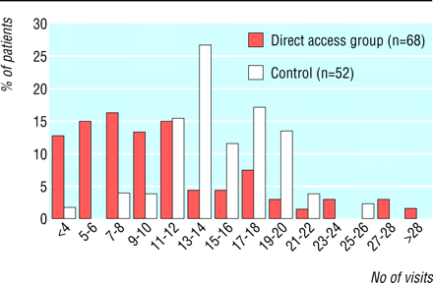
Clinical outcome at six years -There were no significant differences between the groups in median change scores for clinical outcome, except for range of movement in the elbow, where the direct access group deteriorated less. Quality of life at four and six years was not significantly different between the groups.
Appointments with rheumatologist and general practitioners - Direct access patients had 38% fewer hospital reviews over six years (median 8 (5-13) v 13 (11-17), P < 0.0001) with 34% of direct access patients receiving more than 10 hospital reviews compared with 85% of control patients. Fourteen direct access patients (21%) did not request an appointment during the first two years, 19 (28%) during years two to four, and 14 (21%) during years four to six. This includes three patients who did not request any appointments over the six years. The number of visits to the general practitioner for consultations about arthritis was not significantly different between the groups over the six years (median 8, 3-20; v 9.5, 3-17).

Reference Material B – (Question 7)

Interventions for the prevention of falls in older adults: systematic review and meta-analysis of randomised clinical trials

John T Chang, Sally C Morton, Laurence Z Rubenstein, Walter A Mojica, Margaret Maglione, Marika J Suttorp, Elizabeth A Roth and Paul G Shekelle
BMJ 2004; 328;680

Each study intervention was classified independently by LZR and by PGS as including up to two of the following components: multifactorial falls risk assessment and management, exercise, environmental modification, or education. If more than two components were described, each investigator chose the two judged to contribute most to the effectiveness of the intervention. Calculations were not performed for inter-rater reliability, but there were essentially no discrepancies in coding the interventions. To minimise detection bias, each investigator received only the methods sections for each article, retyped but with no identifiers. Exercise components were further characterised as balance, endurance, flexibility, or strength, based on the description of the intervention. Walking programmes were classified as endurance exercise.

Reference Material C – (Question 8)

Interventions for the prevention of falls in older adults: systematic review and meta-analysis of randomised clinical trials

Data for the meta-analysis of participants who fell at least once came from 26 intervention groups in 22 studies (Fig 1).

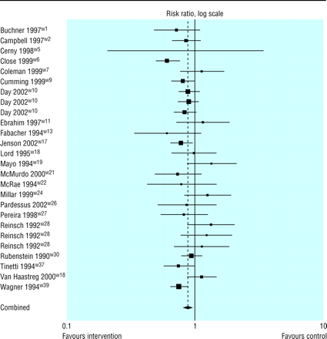

Fig 1 Pooled risk ratio of participants who fell at least once

None of the studies directly assessed the relative effectiveness of intervention components. To assess such effectiveness we therefore compared the magnitude of the effect of each of the components to a control group that received usual care. We entered all studies in the meta-regression model that assessed the effect of individual components while controlling for other components (Table 1).

Continued: Table 1 overleaf
Table 1 Meta-regression estimates of effect of individual intervention components controlling for other intervention components

 | Participants who fell at least once* |  |  | Monthly rate of falling
Treatment component | No of studies (comparison pairs) | Adjusted risk ratio (95% CI) | Number needed to treat | No of studies (comparison pairs) | Adjusted incidence rate ratio (95% CI) | Fewer falls in treatment group
Multifactorial falls risk assessment and management programme | 10 (10) | 0.82 (0.72 to 0.94) | 11 | 7 (7) | 0.63 (0.49 to 0.83) | 11.8
Exercise | 13 (15) | 0.86 (0.75 to 0.99) | 16 | 19 (21) | 0.86 (0.73 to 1.01) | 2.7
Environmental modifications | 5 (4) | 0.90 (0.77 to 1.05) | NA | 5 (6) | 0.85 (0.65 to 1.11) | NA
Education | 2 (3) | 1.28 (0.95 to 1.72) | NA | 1 (1) | 0.33 (0.09 to 1.30) | NA

NA=not applicable.
* R²=0.29.
R²=0.16.
Per 100 patients a month.

